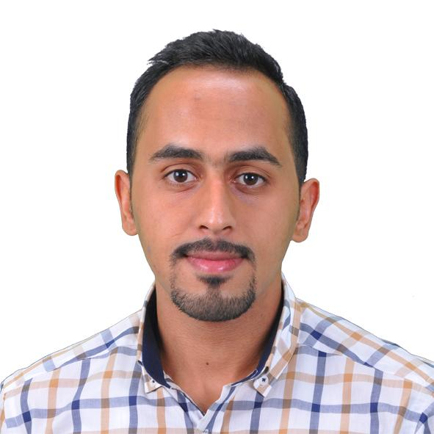
CURRICULUM VITAE

NAME: | Omar Laith Yasin
ADDRESS: | Al Salam Quarter
EMAIL: | Omarlaith23@gmail.com
MOBILE: | +964 771 4889841
CITIZENSHIP: | Iraqi
D.O.B.: | 15/9/1994
MARITIAL STATUS: | Single

QUALIFICATIONS & SKILLS

- Good management and leadership skills
- Fast Learner and work well with others
- Excellent communication skills

EDUCATION:

2013-2017 computer Tech.Eng - IT
Al-Nisour University College
Baghdad, Iraq

EXPERIENCE
- Working on (MTCNA & UBNT) system
- Work on Gas turbine frame9e in IFC .
- Boiler operator in IFC .
- Gas receiver supply in IFC .
- Owner tower for internet service with EarthLink company
- Work on Al Bayan Accounting and warehouses
- Work with all office program (2003,2007,2010,2013)
- Work on all windows and its tools
- Work on internet programs (send and receive Email)

LANGUAGES KNOWN

Language | Write | Speak | Read
Arabic | Excellent | Excellent | Excellent
English | Very Good | Very Good | Very Good

